Development plan

I will be developing the landing screen and the login/register screen. The landing screen will give basic information about the surgery and its services as well as contact details etc. The login screen will be functional and allow users to put in their usernames and passwords to gain access to their accounts which will display specific options based on their level of clearance. The register button will allow new patients to be created. It will not allow new doctors or admins to be created. This is only a feature an admin will have access to. This means that no new people with high enough privileges to cause harm can enter the database without the approval of an admin. This increases the security of the system significantly since the only access new patients have is the ability to view their own appointments, book appointments, cancel appointments and log out.

Here is how I imagine the design should look:
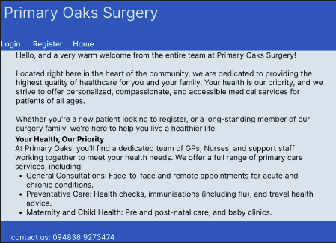
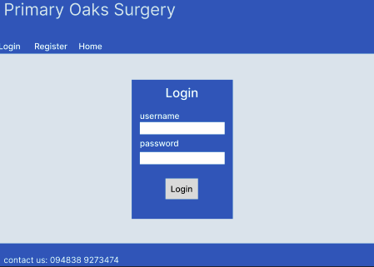
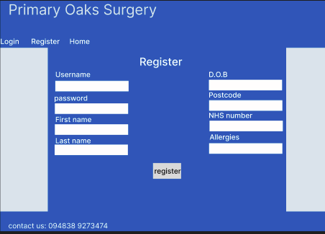

Page 1:
This is just a simple landing page giving a bit of detail about the surgery itself and what services it offers. This can be changed at a later date quite easily to better fit the surgery.

Page 2:
This is a simple login page that will allow users to login to previously made accounts via the register page. It will take the field of username and password.

Page 3:
this page is the bulk of the data. This is where a new user can register themselves and put in valuable information for the surgery to use. This will have the function of the password checker and will only register the user if they have a unique username and have a password that fits the criteria so that a users account interacts with the database correctly and meets a good standard for password security

After having developed the website, I have found my design was not ideal for development and from a design perspective, this is only from a cosmetic perspective however and the functionality remains the same.

This is how the website looks in reality:
landing page:
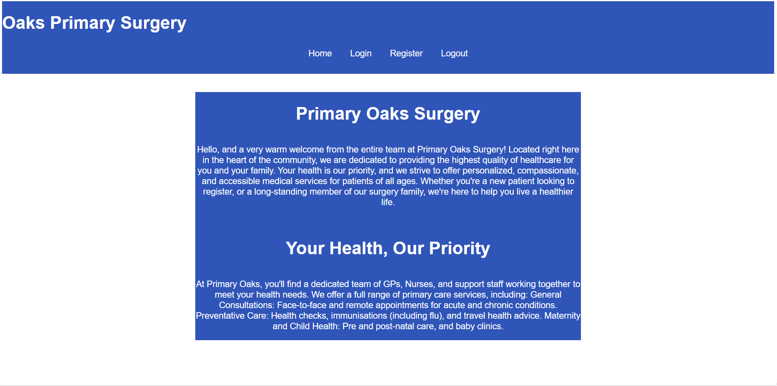
login page:

register page:

the functionality of the website remains the same. It has an added functionality of the ability to log out the user for extra security.

